KNN Classifier
Output 1 (10,000 data input)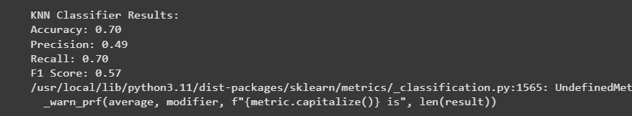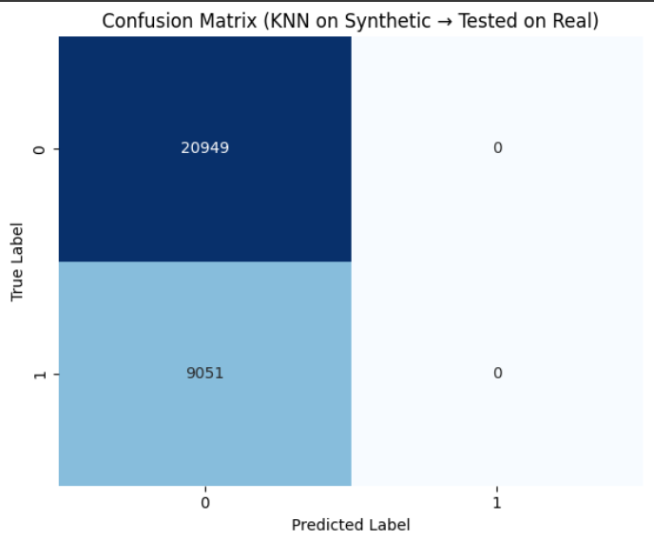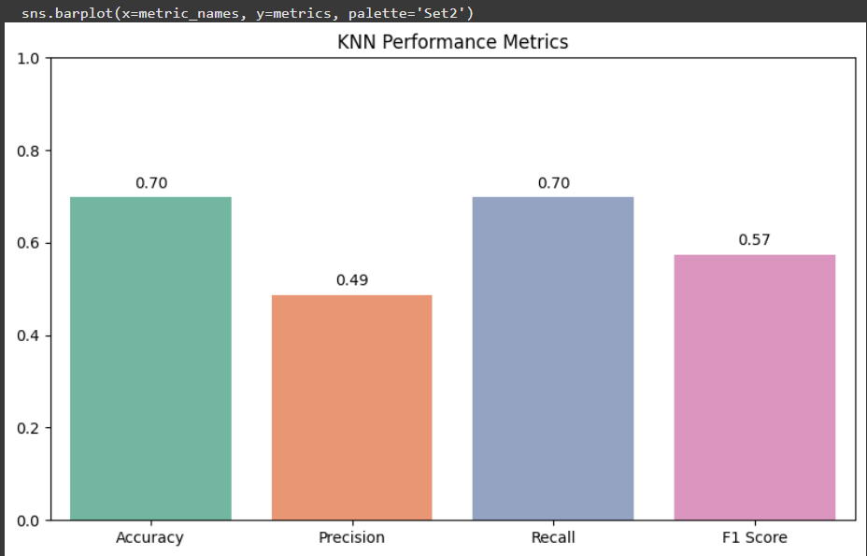

Output 2
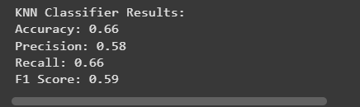

Output 3 (10,000 data)
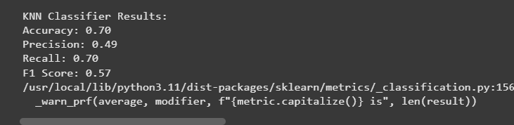

Output 4 (8,000 data)
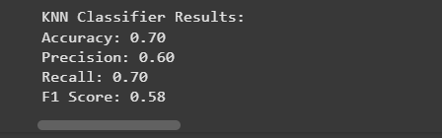

Preprocessing Technique:
Hyperparameter tuning Output